ALUMNEX CONNECT
JIRA-BASED AGILE PROJECT EXECUTION
AND MANAGEMENT REPORT
Ready-to-Submit Project Documentation
Project | Alumnex Connect - Integrated Alumni-Student Mentorship and Career Ecosystem
Jira Project | Alumnex Connect (KAN)
Jira Board | KAN board
Agile Approach | Agile product management with Scrum governance and flow-based Jira workflow
Documentation Date | 06 October 2026
Prepared For | Academic project review / viva / project documentation

Academic evidence note: This report documents the Jira project-management record and current workspace state. It does not claim that the current Jira workspace contains historical Scrum Sprint execution. The connected KAN board is a simple/team-managed board without native Jira Scrum Sprint history.

Department of Computer Science and Engineering
Kongu Engineering College (Autonomous)

Document Control
Item | Record
Document title | Alumnex Connect - Jira-Based Agile Project Execution and Management Report
Project identifier | KAN
Primary management tool | Jira Software / Alumnex Connect
Documentation repository | Confluence - My first space
Reporting basis | Connected Jira/Confluence workspace and uploaded Jira/Confluence evidence exports
Evidence date | 06 October 2026
Status | Prepared for academic submission

Table of Contents
- 1. Executive Summary
- 2. Introduction and Project Context
- 3. Agile Methodology Adopted
- 4. Requirements-to-Jira Transformation
- 5. Jira Project Configuration
- 6. Product Backlog Structure
- 7. User Stories and Acceptance Criteria
- 8. Estimation and Story Points
- 9. Board Workflow and Work-State Management
- 10. Implementation Subtasks and Traceability
- 11. Release and Phase Management
- 12. Dependency Management
- 13. Defect Management
- 14. Scrum Governance and Ceremonies
- 15. Definition of Ready and Definition of Done
- 16. Jira Reporting, Metrics and Evidence
- 17. Confluence Documentation and Knowledge Management
- 18. How Agile Methodologies Apply to Alumnex Connect
- 19. Project Execution Record
- 20. Challenges, Constraints and Academic Reporting Rules
- 21. Results and Outcomes
- 22. Conclusion
- Appendix A - Epic Register
- Appendix B - Story Register
- Appendix C - Subtask Register
- Appendix D - Bug Register
- Appendix E - Screenshot Evidence Log
- References

1. Executive Summary
Alumnex Connect is an integrated alumni-student ecosystem containing authentication, mentorship, developer intelligence (DevPulse), career and jobs, AI career support, real-time communication, community, mobile access, and security/reliability capabilities. The Jira workspace was organized so that these capabilities can be managed as a coherent Agile product rather than as an unstructured list of features.
The verified Jira project contains 10 Epics, 53 Stories, 20 Subtasks and 5 Bugs, giving 88 Jira issues in total. Five Jira Versions divide the backlog into delivery phases. The workflow uses Idea, To Do, In Progress, In Review and Done. The uploaded Jira evidence and current connected Jira state show that the board has been populated across multiple work states rather than leaving all work in the initial backlog state.
The practical Scrum reference supplied for this report describes a flow from requirements gathering to backlog creation, Epic and Story decomposition, estimation, Sprint Planning, task/subtask execution, Daily Scrum, testing, bug fixing, Sprint Review, feedback, Retrospective and reporting. Those concepts have been mapped to Alumnex Connect, while the Jira configuration limits are explicitly separated from the Scrum process model.
Key project-management result: The report establishes a traceable management chain: product capability -> Epic -> user Story -> acceptance criteria -> implementation Subtask -> workflow state -> release phase -> dependency/defect evidence -> documentation and metrics.

2. Introduction and Project Context

2.1 Project context
Alumnex Connect is designed as an integrated digital ecosystem connecting students and alumni through mentorship, career opportunities, developer activity tracking, AI-assisted career guidance, communication, community participation and mobile access. The Jira backlog groups the product around these functional areas and adds a dedicated governance layer for Agile project management.

2.2 Project management objective
The objective of using Jira is to make work visible, decomposable, traceable and reviewable. Jira acts as the operational record for backlog items, status, defects, dependencies and release grouping; Confluence holds the narrative rules, ceremony guidance, quality gates and project knowledge.

2.3 Why Agile fits the project
The product contains multiple interacting capabilities, external integrations, mobile behavior, AI services and reliability concerns. An incremental Agile model is therefore useful because functionality can be broken into small deliverables, risks can be surfaced as visible work, feedback can be incorporated, and releases can be organized in phases.

3. Agile Methodology Adopted
The project is best described as an Agile implementation with four complementary lenses: Scrum for governance and iterative planning, Kanban for visible work flow, XP for engineering quality practices, and Lean for reducing waste and improving flow.
Methodology | How it contributes | Application in Alumnex Connect
Scrum | Product Backlog, Stories, estimates, Sprint Planning, Daily Scrum, Review, Retrospective, DoR and DoD. | Documented in KAN-55 to KAN-63 and the Confluence playbook; native Jira Sprints are not available on the current board.
Kanban | Visible workflow, WIP awareness, bottlenecks, cycle time and continuous flow. | Implemented directly through the KAN board workflow: Idea -> To Do -> In Progress -> In Review -> Done.
XP | Automated testing, CI/CD, continuous integration, small increments and engineering quality. | Represented by KAN-52 Automated Testing, KAN-53 CI/CD Pipeline and KAN-50 Security Hardening; specific historical XP practices require independent evidence.
Lean | Reduce waste, limit unnecessary handoffs, expose blockers, optimise value delivery and use feedback for improvement. | Supported by visible workflow, dependency links, release phases and the continuous-improvement governance item KAN-63.

3.1 Reference Scrum process used for mapping
The supplied Practical Scrum Process Using Jira document explains a complete example beginning with customer requirements, conversion into User Stories, Epic grouping, priority and Story Point estimation, Sprint creation, task/subtask decomposition, assignment, development, Daily Scrum, testing, bug lifecycle, Story completion, Sprint Review, customer feedback, Retrospective, Sprint completion and reporting. The same lifecycle is used in this report as the reference framework for explaining where each Alumnex Jira artifact fits.

4. Requirements-to-Jira Transformation
The first Agile transformation is from broad product requirements into manageable backlog items. Instead of maintaining all functionality as large feature statements, the project converts capabilities into Epics and then into user-value Stories.
Agile step | Alumnex Connect application
Requirement capture | Identify the user or business outcome to be delivered.
Epic grouping | Group related functionality into a coherent product capability.
User Story creation | Express a feature using the user/goal/benefit pattern.
Acceptance criteria | Define observable conditions that determine whether the Story is complete.
Estimation | Record a relative effort/complexity estimate.
Implementation decomposition | Create Subtasks for the technical work needed to satisfy the Story.
Workflow execution | Move work through the board as it is refined, developed and reviewed.
Quality and feedback | Track Bugs and review evidence before marking work complete.
Release grouping | Assign work to the appropriate delivery phase.

4.1 Evidence: Jira backlog
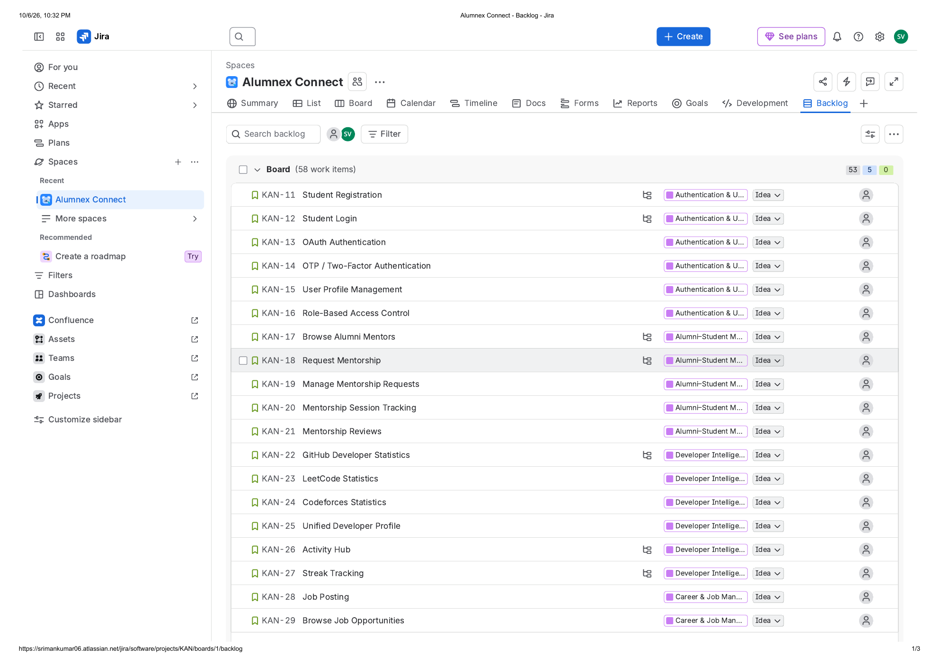
Figure 1. Jira Backlog view showing the Alumnex Connect backlog and grouped Epic/Story structure.
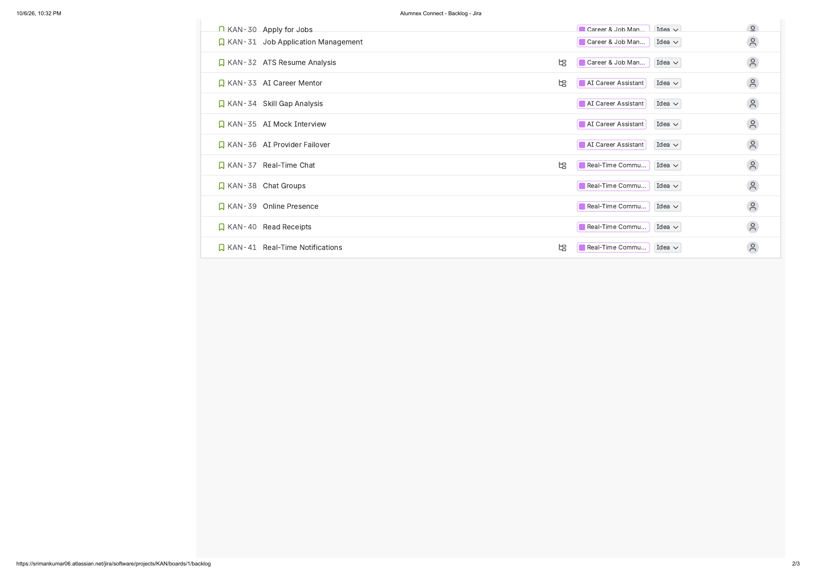
Figure 2. Continued Jira Backlog view showing additional Alumnex Connect Stories.

5. Jira Project Configuration
The connected workspace identifies the project as Alumnex Connect (KAN) with a built-in board named KAN board. The board is a simple/team-managed configuration. The verified board columns are Idea, To Do, In Progress, In Review and Done.
Configuration item | Verified value
Project key | KAN
Project type | Team-managed / simple
Board | KAN board
Workflow | Idea -> To Do -> In Progress -> In Review -> Done
Issue types in the project | Epic, Story, Subtask, Bug
Jira Versions | 5 delivery phases
Recorded dependency links | 8 Blocks links
Confluence space | My first space (MFS)
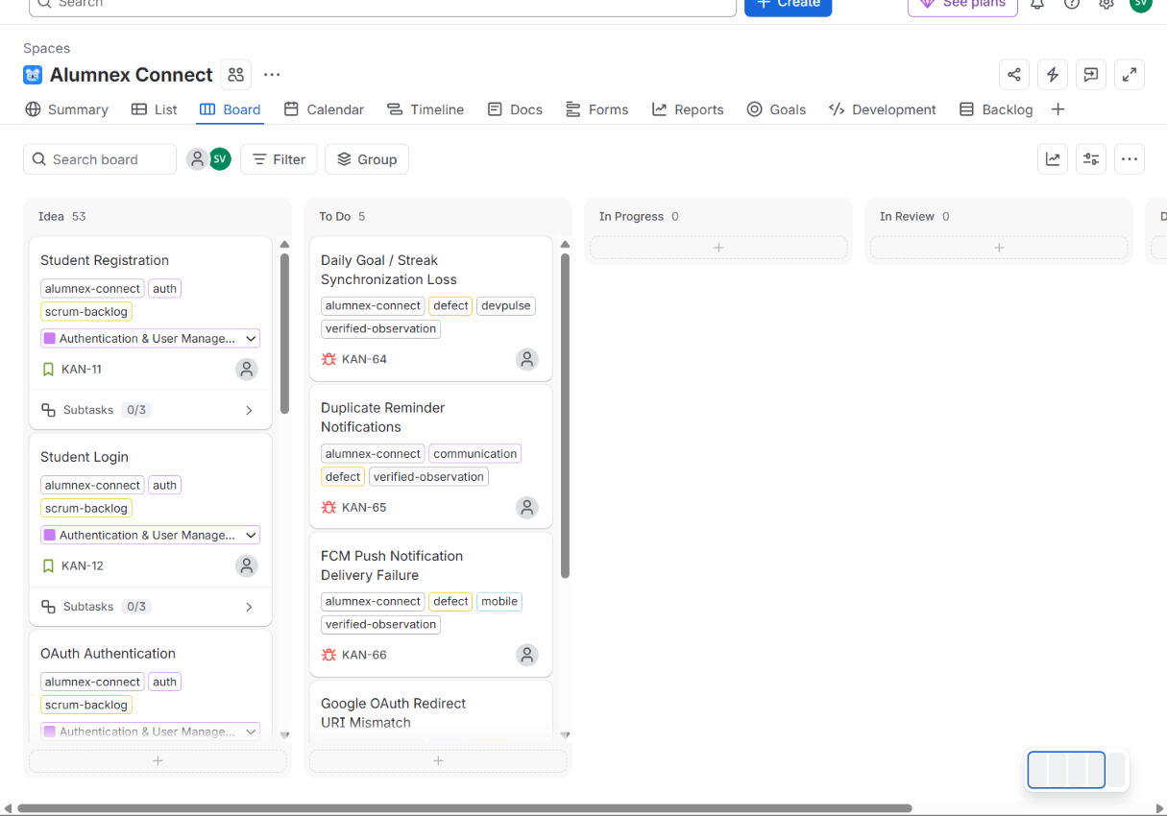
Figure 3. User-provided Jira Board screenshot before workflow population: 53 board Stories were in Idea and 5 Bugs were in To Do.

6. Product Backlog Structure
The backlog is organized into four principal issue layers. Epics provide the strategic capability boundary. Stories represent user-value increments. Subtasks represent implementation activities. Bugs represent quality deviations that require corrective work.
Issue type | Purpose | Agile role
Epic | Large capability or outcome | Roadmap and product structure
Story | User-visible outcome | Product Backlog and incremental delivery
Subtask | Concrete implementation activity | Development execution and traceability
Bug | Observed defect/deviation | Quality management and release readiness

6.1 Epic register
Key | Epic | Purpose
KAN-1 | Authentication & User Management | Identity, registration, login, OAuth, OTP, profiles, RBAC
KAN-2 | Alumni-Student Mentorship | Mentor discovery, requests, sessions, reviews
KAN-3 | Developer Intelligence - DevPulse | Coding-platform integrations, activity hub and streaks
KAN-4 | Career & Job Management | Job posting, browsing, applications and ATS
KAN-5 | AI Career Assistant | AI mentor, skill-gap analysis, mock interview and failover
KAN-6 | Real-Time Communication | Chat, groups, presence, read receipts and notifications
KAN-7 | Community & Events | Forum, events and alumni networking
KAN-8 | Mobile Application | Android wrapper, mobile authentication, responsive UI and push
KAN-9 | Security, Reliability & DevOps | Security hardening, failover, testing, CI/CD, monitoring
KAN-10 | Scrum & Project Governance | Backlog, ceremonies, quality gates, risks, releases and metrics

7. User Stories and Acceptance Criteria
The Stories follow the user-story structure described in the supplied Scrum reference: As a <user>, I want to <perform an action>, so that <benefit>. In Alumnex Connect, the descriptions also include explicit Acceptance Criteria and a Suggested estimate. This combination supports backlog refinement, implementation and review.
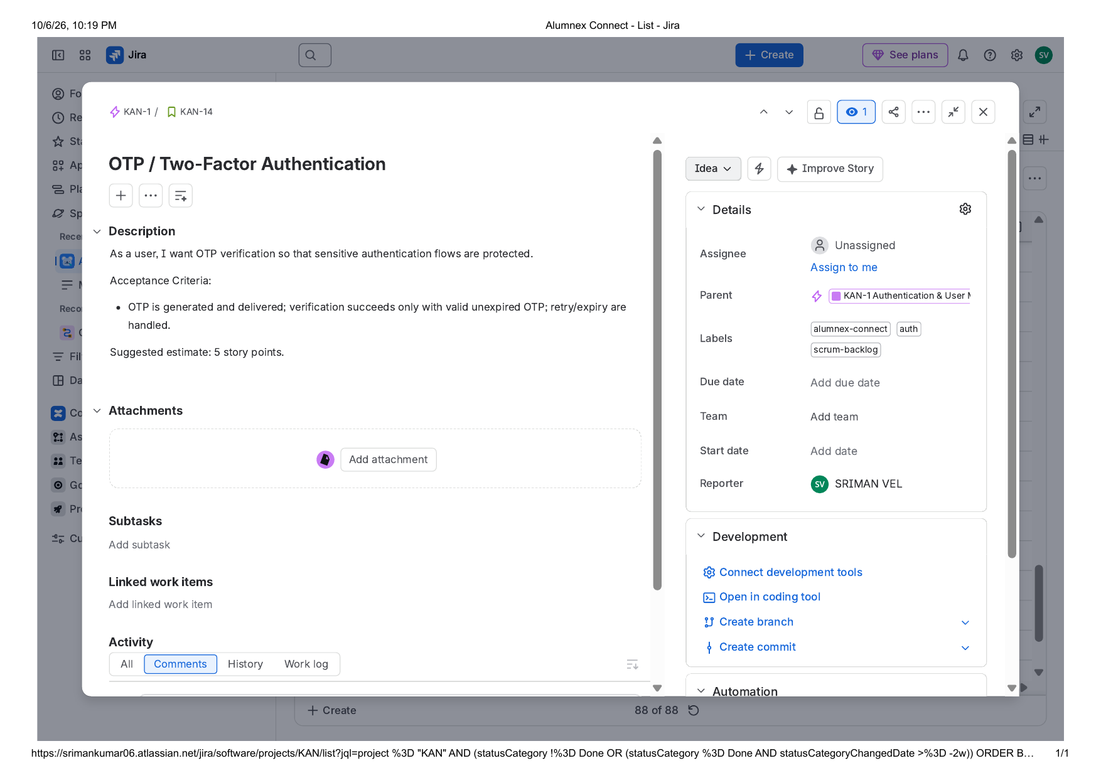
Figure 4. Jira Story detail example (KAN-14 OTP / Two-Factor Authentication) showing user story text, acceptance criteria, estimate, parent Epic and project labels.
For example, KAN-14 defines OTP behavior and explicitly states that valid, unexpired OTPs must succeed while retry and expiry handling must be supported. The Jira record also shows the parent Epic, labels, reporter and the suggested estimate. This is the level of detail expected for a refined backlog item.

8. Estimation and Story Points
All 53 Jira Stories contain a Suggested estimate value in the description. The distribution is 29 Stories at 5 points, 15 Stories at 3 points, 8 Stories at 8 points, and 1 Story at 2 points, giving a total of 256 suggested points. The supplied Story Point Baseline document explicitly states that these values are a planning baseline and not a claim of historical Sprint execution.
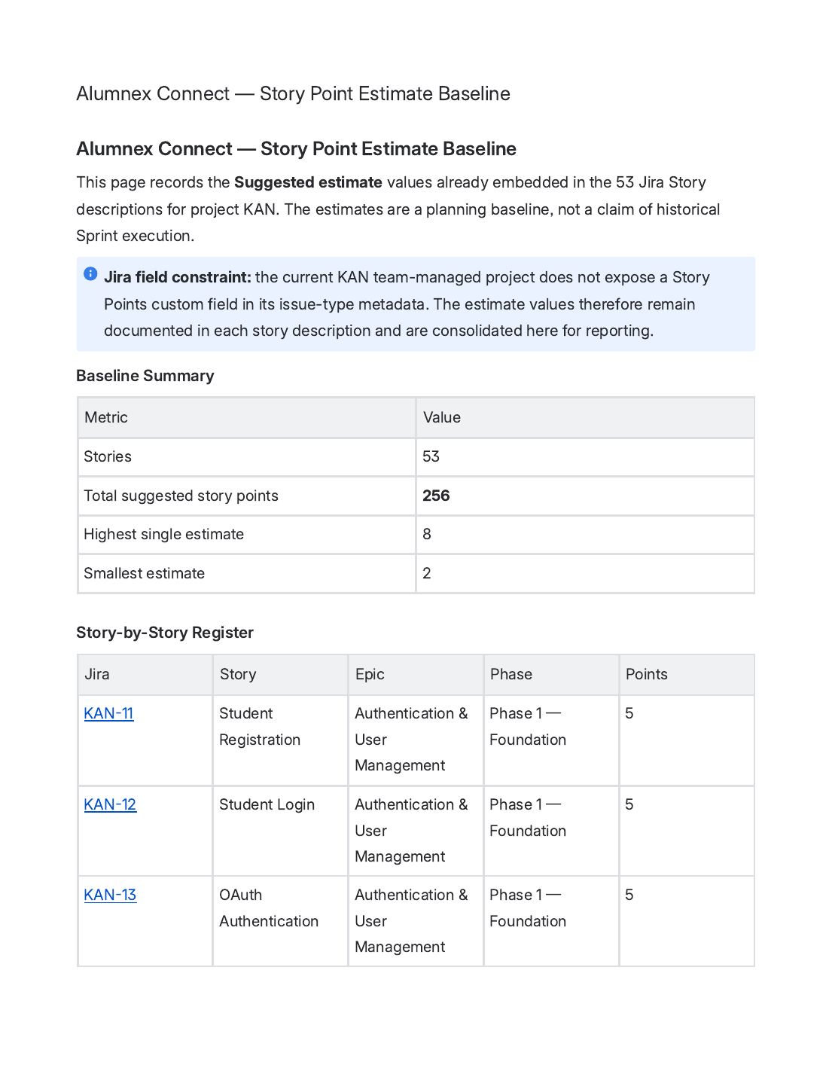
Figure 5. Story Point Estimate Baseline exported from Confluence/Jira documentation, showing the 53-story / 256-point baseline.
Jira configuration constraint: The KAN team-managed project does not expose a Story Points custom field in its issue-type metadata. The estimates are therefore retained in Story descriptions and in the baseline documentation instead of being represented as a nonexistent native field.

9. Board Workflow and Work-State Management
The board workflow is used as the project execution layer. Each state communicates where a work item is in its delivery lifecycle.
Board state | Operational meaning
Idea | Potential work or high-level capability not yet in execution
To Do | Refined work that is queued or awaiting execution
In Progress | Implementation actively underway
In Review | Testing, peer review or acceptance validation
Done | Work has passed the project quality/completion gate

9.1 Board population record
The board screenshot supplied at the beginning of the workflow showed 53 Story items in Idea, 5 Bugs in To Do, and zero board items in In Progress, In Review or Done. Subsequent Jira evidence shows the board populated across multiple workflow states. The current whole-project Jira Summary snapshot reports 88 total issues with 38 Done, 11 In Progress, 9 In Review, 20 To Do and 10 Idea; the 10 Idea issues are the Epic containers, while the board itself displays the 58 Story/Bug work items.
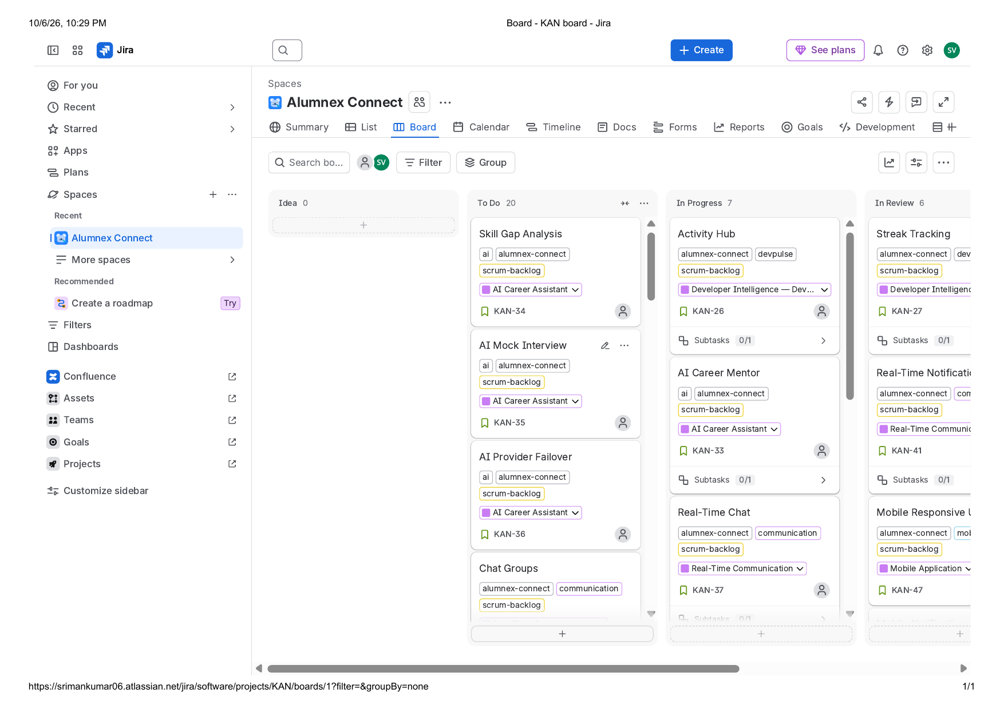
Figure 6. Jira Board evidence export after workflow population, showing To Do, In Progress and In Review work states; board work items are the executable Story/Bug layer.
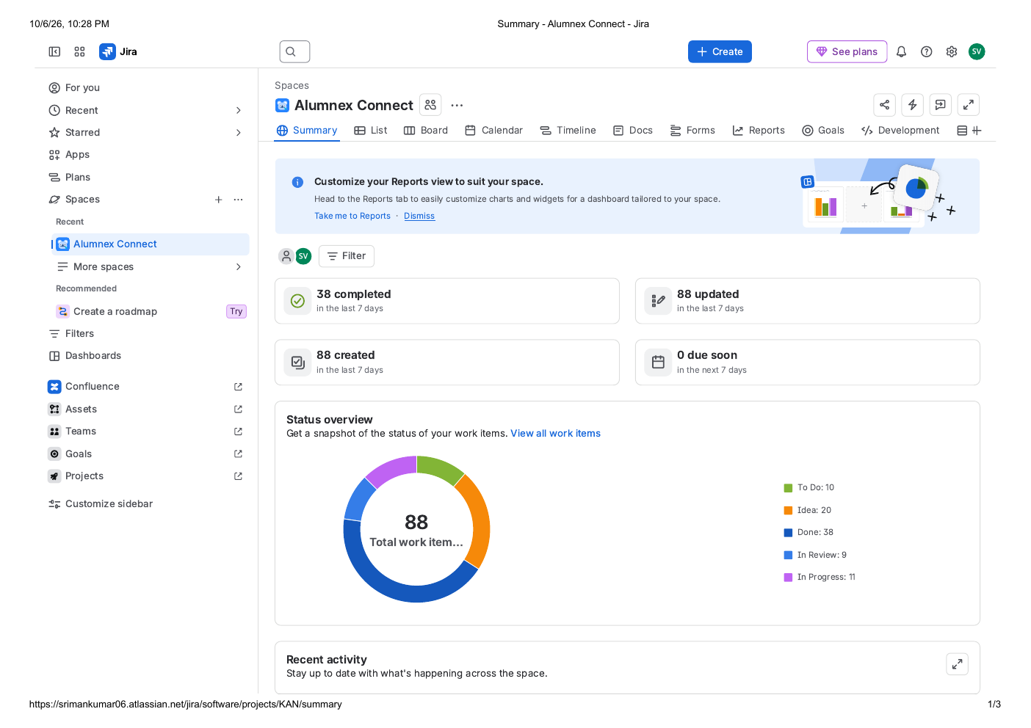
Figure 7. Jira Summary snapshot dated 06 October 2026 showing 88 total work items and the current distribution: 38 Done, 11 In Progress, 9 In Review, 20 To Do and 10 Idea.
Interpretation for an academic report: These status values are a current Jira management snapshot created to organize the project backlog and work-state view. They must not be presented as historical Sprint completion records.

10. Implementation Subtasks and Traceability
Twenty Subtasks were created so that implementation work can be connected to its parent Story. This is consistent with the practical Scrum reference, which recommends decomposing Stories into smaller technical tasks and then tracking their movement through the board.
Subtask | Work item | Parent Story
KAN-69 | Design registration flow | KAN-11
KAN-70 | Implement secure credential handling | KAN-11
KAN-71 | Registration tests | KAN-11
KAN-72 | Implement login flow | KAN-12
KAN-73 | Handle authentication failures | KAN-12
KAN-74 | Login tests | KAN-12
KAN-75 | Mentor search and filters | KAN-17
KAN-76 | Mentorship request workflow | KAN-18
KAN-77 | Mentorship request tests | KAN-18
KAN-78 | GitHub integration | KAN-22
KAN-79 | Activity aggregation | KAN-26
KAN-80 | Streak calculation | KAN-27
KAN-81 | Resume PDF extraction | KAN-32
KAN-82 | ATS scoring | KAN-32
KAN-83 | AI chat integration | KAN-33
KAN-84 | Socket messaging | KAN-37
KAN-85 | Notification deduplication | KAN-41
KAN-86 | Android wrapper | KAN-45
KAN-87 | FCM registration | KAN-48
KAN-88 | Security review | KAN-50
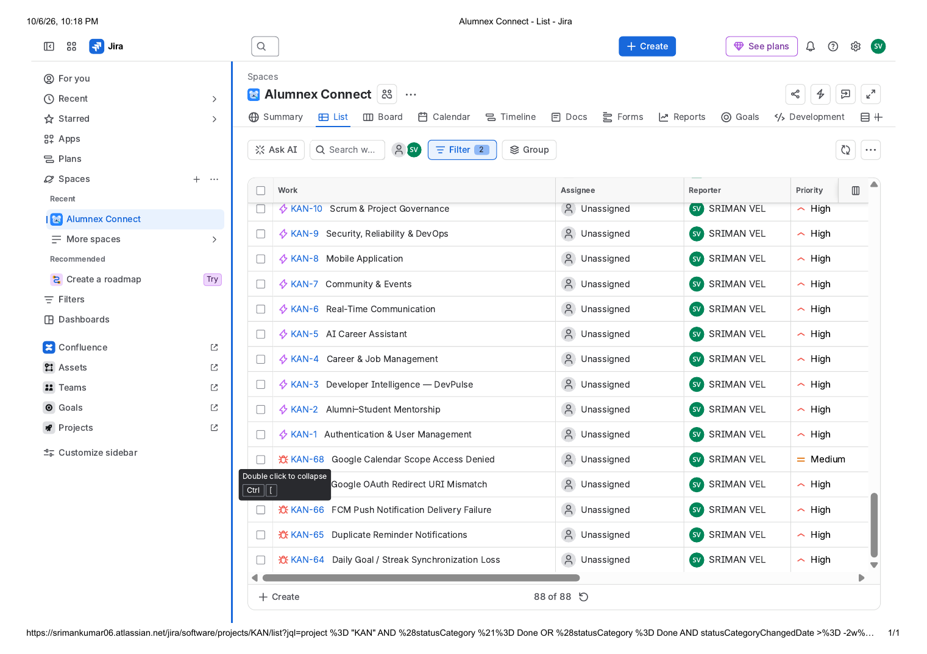
Figure 8. Jira List view showing implementation Subtasks and their traceable work items.

11. Release and Phase Management
Five Jira Versions were created to group work into coherent delivery phases. This creates a roadmap/release layer above the individual Story workflow.
Jira Version | Scope
Phase 1 - Foundation | Authentication, profiles, RBAC and platform foundation.
Phase 2 - Mentorship & Career | Mentorship workflows, jobs, applications and ATS.
Phase 3 - DevPulse | Developer integrations, activity hub and streak tracking.
Phase 4 - AI & Communication | AI career capabilities, chat and notifications.
Phase 5 - Mobile & Reliability | Mobile experience, security, failover, testing and monitoring.
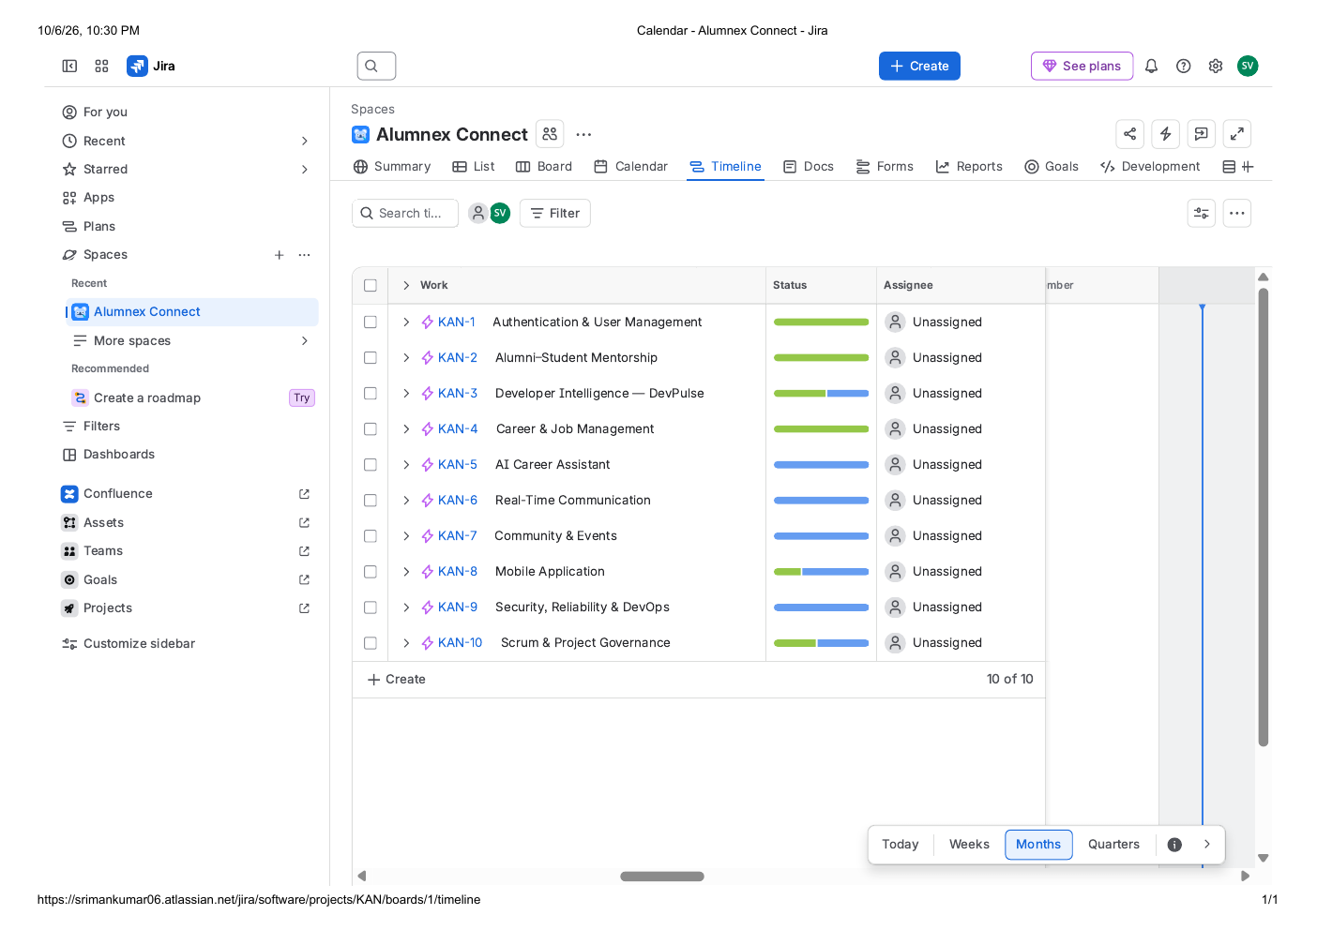
Figure 9. Jira Timeline view displaying the Epic-level product structure across the project roadmap.
In Agile terms, Versions are useful for release planning, while Sprints (when available) are time-boxed iteration contexts. The current KAN configuration provides the release-phase layer but not native Scrum Sprint execution.

12. Calendar and Scheduling View
The Calendar view provides a date-based perspective for work planning. The evidence export shows unscheduled work and makes it possible to assign due dates by dragging work items onto calendar dates. This supports scheduling and coordination, but does not by itself create a Sprint.
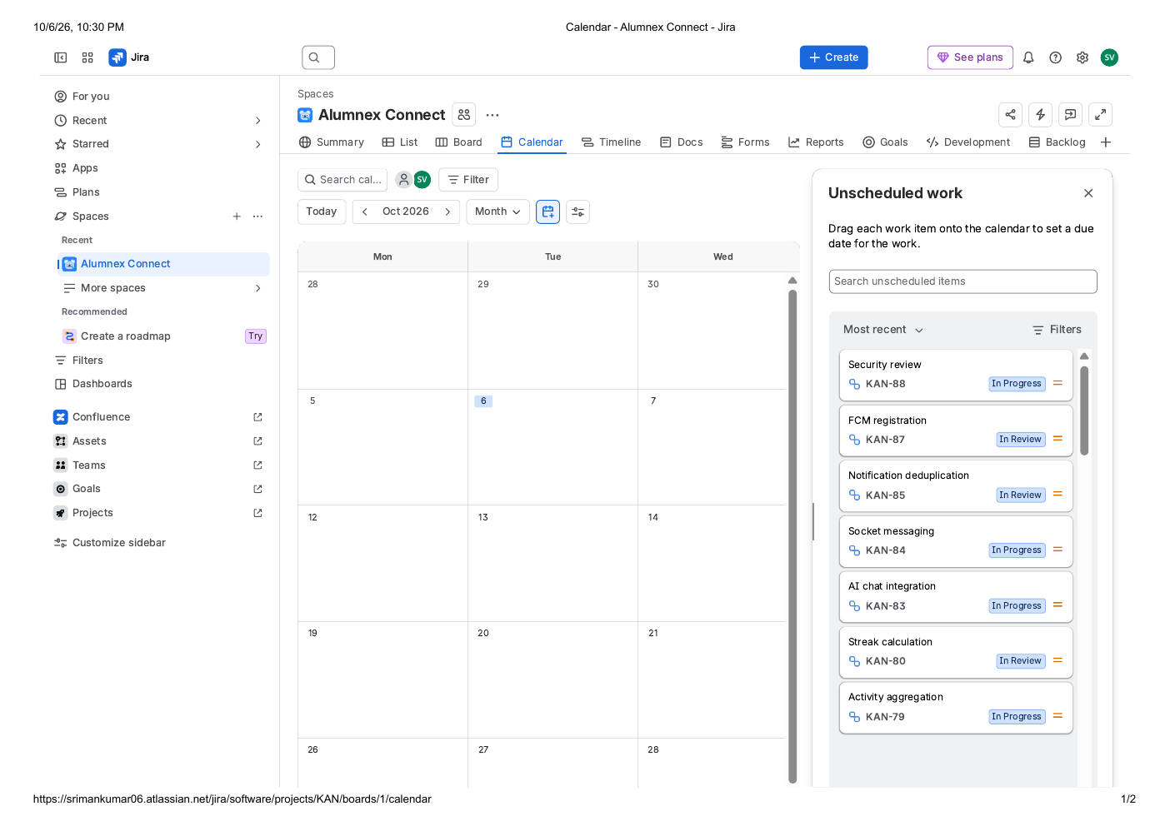
Figure 10. Jira Calendar view showing unscheduled work and work-state information.

13. Dependency Management
Eight issue links of type Blocks were created to make sequencing and risk visible. Dependency tracking is important because a technically valid Story may still be unable to progress until an upstream capability is available.
Source | Relationship | Target
KAN-33 | blocks | KAN-36
KAN-45 | blocks | KAN-46
KAN-48 | blocks | KAN-66
KAN-26 | blocks | KAN-64
KAN-41 | blocks | KAN-65
KAN-13 | blocks | KAN-67
KAN-33 | blocks | KAN-68
KAN-50 | blocks | KAN-52
Refinement note: During future backlog refinement, every Blocks relationship should be revalidated. If a relationship is informational rather than a hard sequencing constraint, a Relates link is more accurate than Blocks.

14. Defect Management
The project contains five observed/reported defects. Their descriptions include an observed problem statement, fix/acceptance criteria and a verification note. This is consistent with the supplied Scrum reference, which treats Bugs as visible work that progresses through an engineering lifecycle rather than being hidden outside the backlog.
Bug | Problem | Area | Fix / acceptance intent
KAN-64 | Daily Goal / Streak Synchronization Loss | DevPulse | Persist goal completion, reconcile missed events, idempotent sync, expose last-sync timestamp.
KAN-65 | Duplicate Reminder Notifications | Communication | Deduplicate by notification/event ID, coordinate delivery channels and add delivery logging.
KAN-66 | FCM Push Notification Delivery Failure | Mobile | Validate FCM token lifecycle, credentials, retries and safe delivery logging.
KAN-67 | Google OAuth Redirect URI Mismatch | Authentication | Align authorized redirect URIs with the active backend callback configuration.
KAN-68 | Google Calendar Scope Access Denied | Career / Calendar | Review scopes and consent configuration, handle denial gracefully and document requirements.
All five Bugs are currently in To Do. They are explicitly marked in Jira as observed/reported defects and should be verified against the current implementation before being closed.
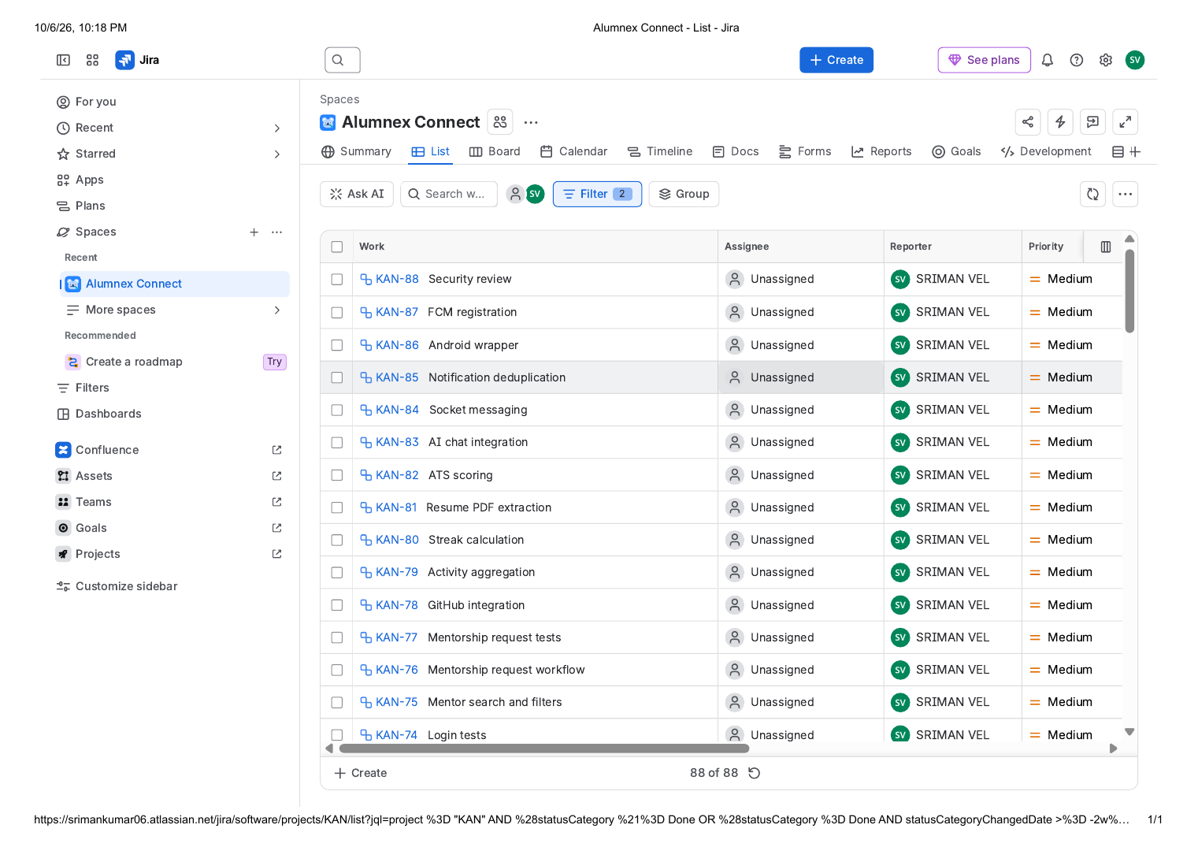
Figure 11. Jira List view showing the project work-item register, including Subtasks and reported Bugs.

15. Scrum Governance and Ceremonies
The governance layer is represented by KAN-55 through KAN-63 under the Scrum & Project Governance Epic. These issues define how a Scrum-style operating model would be run around the existing backlog.
Jira Story | Ceremony / governance practice | Application
KAN-55 | Product Backlog & Refinement | Maintain clear outcomes, acceptance criteria and priorities.
KAN-56 | Sprint Planning | Define Sprint Goal, selected work, estimates and capacity.
KAN-57 | Daily Scrum Tracking | Inspect progress, blockers and plan adjustments.
KAN-58 | Sprint Review & Stakeholder Feedback | Demonstrate increments and capture feedback.
KAN-59 | Sprint Retrospective & Improvement Actions | Convert lessons into actionable improvements.
KAN-60 | Definition of Ready & Definition of Done | Establish readiness and completion quality gates.
KAN-61 | Risk, Dependency & Decision Tracking | Make important project constraints visible and traceable.
KAN-62 | Release & Version Tracking | Connect backlog scope to delivery phases.
KAN-63 | Agile Metrics & Continuous Improvement | Use delivery data for system improvement.
The practical Scrum reference also identifies roles such as Product Owner, Scrum Master, Developers and Tester. For Alumnex Connect, those roles are used as a process model; the connected Jira exports do not by themselves provide historical meeting attendance or role-assignment records, so this report does not invent such evidence.

15.1 Confluence documentation templates and where they fit
Template | Main content | Agile application
Project plan template | Driver, approver, contributors, objective, scope, timeline, milestones and status. | Project initiation, release planning and stakeholder alignment.
Meeting notes template | Date, participants, goals, discussion topics, action items, decisions and related information. | Daily Scrum, Sprint Planning, Review, Retrospective and stakeholder meetings.
Weekly status report template | Wins, needs input, focus, notes and important links. | Weekly stakeholder communication and management reporting.

16. Definition of Ready and Definition of Done

16.1 Definition of Ready (DoR)
- The user outcome is clear and valuable.
- Acceptance criteria are testable.
- Dependencies are known or explicitly tracked.
- Scope is small enough for the intended iteration.
- The team can explain what evidence will demonstrate success.

16.2 Definition of Done (DoD)
- Implementation is complete against the Story scope.
- Acceptance criteria are satisfied.
- Relevant automated/manual tests are completed.
- Code or implementation review is completed where applicable.
- Security/privacy considerations are addressed where relevant.
- Release/deployment requirements are satisfied when applicable.
- Required documentation is updated.
Agile application: DoR protects the quality of work entering execution; DoD protects the quality of work leaving execution. Together they create explicit quality gates rather than relying on a status label alone.

17. Jira Reporting, Metrics and Evidence
Jira provides Summary, Reports, Calendar, Timeline and Development views. The uploaded evidence demonstrates how the project can be reviewed from several angles rather than relying only on a board.
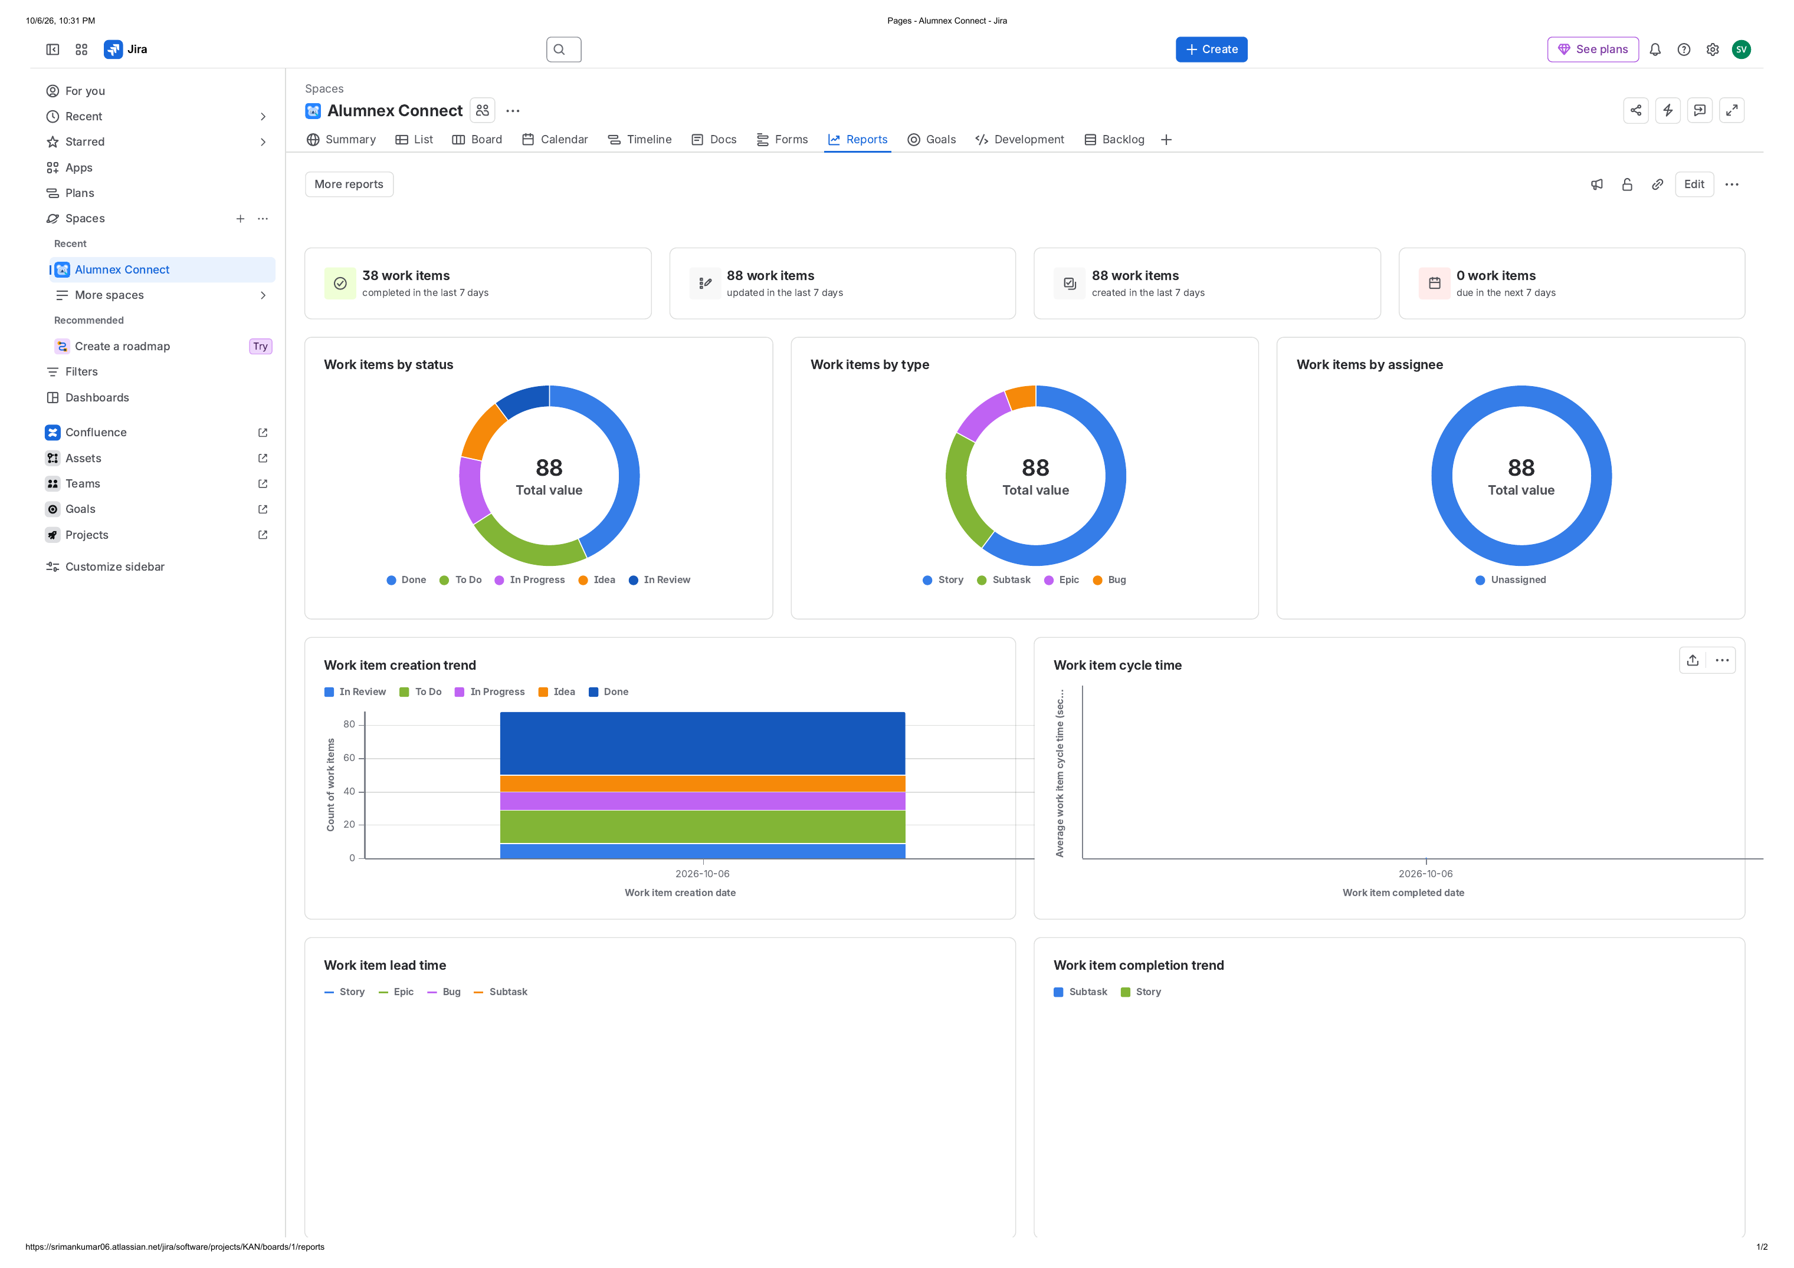
Figure 12. Jira Reports view showing work-item counts by status, type, assignee and trend-based views.
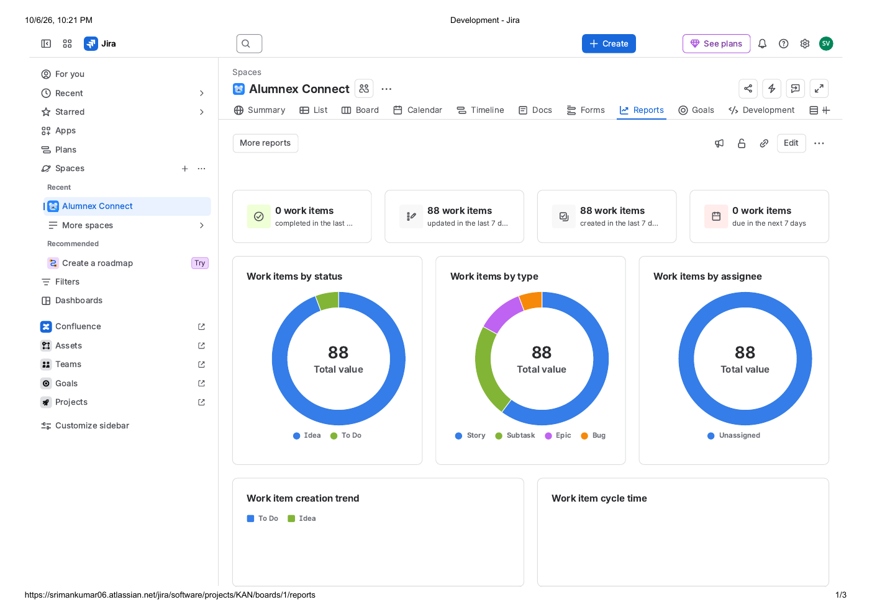
Figure 13. Jira Development view showing development connections and delivery metrics area.
The Reports evidence dated 06 October 2026 shows 38 work items completed in the last 7 days and 88 work items created/updated in that same period. Because the project-management structure was established in this period, these values primarily document Jira setup and state management rather than a historical product velocity.
Recommended Agile metrics for future real iterations are throughput, cycle time, work-item age, WIP, defect trends, release readiness and, after real Scrum Sprints exist, Sprint velocity and planned-versus-completed work.

18. Confluence Documentation and Knowledge Management
Confluence complements Jira by storing the narrative project-management layer. The dedicated Alumnex Connect Jira Project Management & Agile Playbook states that Jira is the source of truth for backlog, work status, defects, dependencies, releases and delivery metrics, while the playbook documents the Scrum model, backlog refinement, Sprint Planning, Daily Scrum, Sprint Review, Retrospective, DoR/DoD, risk/dependency tracking, release tracking and Agile metrics.
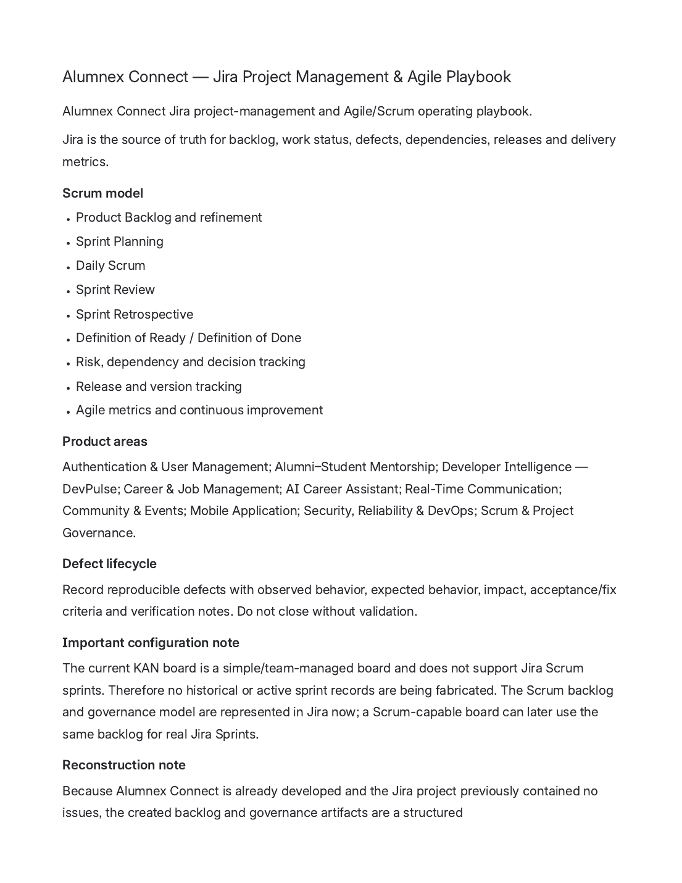
Figure 14. Confluence Agile/Scrum playbook used as the project-management documentation layer.

19. How Agile Methodologies Apply to Alumnex Connect
Artifact / practice | Methodology | Jira evidence | Why it matters
Product Backlog | Scrum | KAN-11 to KAN-63 plus Bugs and Subtasks | Defines and prioritizes the work that can deliver product value.
Epic hierarchy | Scrum / Agile | KAN-1 to KAN-10 | Groups large capability areas into manageable product outcomes.
User Stories | Scrum / Agile | 53 Stories | Express work from the user perspective and create vertical increments.
Acceptance Criteria | Scrum / quality | Story descriptions | Create observable completion conditions for testing and review.
Subtasks | Agile / engineering | KAN-69 to KAN-88 | Break implementation into smaller technical activities.
Workflow board | Kanban | KAN board | Makes flow, WIP and review stages visible.
Story estimates | Scrum / planning | Suggested estimates in 53 Stories | Support relative sizing; future Sprints can use them after native point support exists.
Bugs | Agile quality | KAN-64 to KAN-68 | Treat defects as visible work with fix criteria and verification.
Versions | Release planning | Five Phase Versions | Organize delivery scope by release/phase.
Dependencies | Lean / Scrum planning | 8 Blocks links | Surface sequencing risk and prevent hidden blockers.
DoR / DoD | Scrum | KAN-60 | Control readiness and completion quality.
Retrospective | Scrum / continuous improvement | KAN-59 | Convert experience into process improvements.
Automated testing / CI-CD | XP | KAN-52 / KAN-53 | Reduce regression risk and shorten feedback loops.
Metrics | Kanban / Lean / Scrum | KAN-63 + Jira Reports | Use evidence to improve flow and planning.

20. Project Execution Record
The following sequence records the Jira-based project-management actions represented in the current workspace. It is intended as an auditable management log, not as a claim that every action occurred historically on the same date as the original software-development work.
Step | Execution record
1 | Project structure established: Alumnex Connect / KAN project and KAN board verified.
2 | Epic layer created: 10 product capability Epics created to organize the solution.
3 | Story backlog built: 53 user Stories created with user-oriented descriptions and acceptance criteria.
4 | Implementation decomposition: 20 Subtasks created for selected Stories.
5 | Defect visibility: 5 observed/reported Bugs created with fix/acceptance criteria.
6 | Release grouping: 5 Jira Versions created and non-Epic work assigned to the relevant phase.
7 | Dependencies: 8 Blocks relationships recorded between related work items.
8 | Workflow population: Stories/Subtasks were distributed across To Do, In Progress, In Review and Done to create a meaningful current work-state view.
9 | Estimation baseline: 53 suggested Story estimates consolidated into a 256-point planning baseline.
10 | Governance documentation: KAN-55 to KAN-63 and the Confluence Agile/Scrum playbook established the operating model.
11 | Evidence capture: Backlog, Board, Summary, Calendar, Timeline, Reports, Development and Story-detail views exported for evidence.
12 | Academic documentation: This report consolidates the project-management record and explains the Agile methodology mapping.

20.1 Current project status snapshot
Measure | Current value | Interpretation
Whole Jira project | 88 issues | 10 Epics, 53 Stories, 20 Subtasks, 5 Bugs
Whole-project status | 38 Done / 11 In Progress / 9 In Review / 20 To Do / 10 Idea | Includes Epics and Subtasks
Board work-item layer | 58 displayed Stories/Bugs | 25 Done / 7 In Progress / 6 In Review / 20 To Do / 0 Idea
Release phases | 5 | Phase 1 to Phase 5
Suggested Story Points | 256 | 53 Stories

21. Challenges, Constraints and Academic Reporting Rules
Constraint | Academic treatment
No native Scrum Sprint history | The KAN board is simple/team-managed and does not support native Jira Scrum Sprints. Therefore this report documents Scrum practices as an operating model, not as historical Sprint evidence.
No native Story Points field | The project metadata exposes no Story Points custom field. The 256-point baseline is retained in Story descriptions and documentation.
Observed Bugs require verification | The five Bugs are recorded from observed/reported behavior and should be re-tested against the current implementation before closure.
Dependency semantics | The eight Blocks links should be revalidated during future refinement to ensure that each is truly a blocker.
Assignment evidence | The exported issue views show many items as Unassigned; this report does not invent individual responsibility assignments.
Jira metrics timing | The 06 October 2026 reports show recent creation/update activity because the project-management structure was established recently.

22. Results and Outcomes
- Created a structured Agile backlog with 10 Epics, 53 Stories, 20 Subtasks and 5 Bugs.
- Organized the product into five release/phase Versions.
- Established a visible flow-based Jira board with five workflow states.
- Created traceability between Stories and implementation Subtasks.
- Recorded observed defects with acceptance/fix criteria and verification notes.
- Established dependency visibility through issue links.
- Created a documented estimation baseline of 256 suggested Story Points.
- Added Scrum governance artifacts covering backlog refinement, planning, Daily Scrum, Review, Retrospective, DoR/DoD, risks, releases and metrics.
- Built a Confluence knowledge layer and captured Jira/Confluence UI evidence for the academic report.

23. Conclusion
The Alumnex Connect Jira workspace now provides a structured Agile project-management record connecting product capabilities, user requirements, implementation work, quality issues, release phases, dependencies and governance. The board provides a clear flow-based work view, while Confluence provides the supporting process documentation.
The strongest current methodological fit is a hybrid Agile model: Scrum governs how the backlog should be refined, planned, reviewed and improved; Kanban provides the actual visible workflow in the current team-managed Jira board; XP principles can strengthen engineering quality through automated testing and CI/CD; and Lean principles support waste reduction, short feedback loops and flow improvement.
For a future iteration in which native Scrum reporting is required, the project should be migrated or recreated in a Scrum-capable Jira configuration and the same backlog, acceptance criteria, Subtasks, Bugs and release structure can then be used to manage real time-boxed Sprints.

Appendix A - Complete Epic Register
KAN-1 - Authentication & User Management
Identity, registration, login, OAuth, OTP, profiles, RBAC
KAN-2 - Alumni-Student Mentorship
Mentor discovery, requests, sessions, reviews
KAN-3 - Developer Intelligence - DevPulse
Coding-platform integrations, activity hub and streaks
KAN-4 - Career & Job Management
Job posting, browsing, applications and ATS
KAN-5 - AI Career Assistant
AI mentor, skill-gap analysis, mock interview and failover
KAN-6 - Real-Time Communication
Chat, groups, presence, read receipts and notifications
KAN-7 - Community & Events
Forum, events and alumni networking
KAN-8 - Mobile Application
Android wrapper, mobile authentication, responsive UI and push
KAN-9 - Security, Reliability & DevOps
Security hardening, failover, testing, CI/CD, monitoring
KAN-10 - Scrum & Project Governance
Backlog, ceremonies, quality gates, risks, releases and metrics

Appendix B - Story Register
Jira | Story | Epic | Current status | Suggested points
KAN-11 | Student Registration | KAN-1 | Done | 5
KAN-12 | Student Login | KAN-1 | Done | 5
KAN-13 | OAuth Authentication | KAN-1 | Done | 5
KAN-14 | OTP / Two-Factor Authentication | KAN-1 | Done | 5
KAN-15 | User Profile Management | KAN-1 | Done | 3
KAN-16 | Role-Based Access Control | KAN-1 | Done | 5
KAN-17 | Browse Alumni Mentors | KAN-2 | Done | 5
KAN-18 | Request Mentorship | KAN-2 | Done | 5
KAN-19 | Manage Mentorship Requests | KAN-2 | Done | 5
KAN-20 | Mentorship Session Tracking | KAN-2 | Done | 5
KAN-21 | Mentorship Reviews | KAN-2 | Done | 3
KAN-22 | GitHub Developer Statistics | KAN-3 | Done | 5
KAN-23 | LeetCode Statistics | KAN-3 | Done | 5
KAN-24 | Codeforces Statistics | KAN-3 | Done | 5
KAN-25 | Unified Developer Profile | KAN-3 | Done | 3
KAN-26 | Activity Hub | KAN-3 | In Progress | 8
KAN-27 | Streak Tracking | KAN-3 | In Review | 5
KAN-28 | Job Posting | KAN-4 | Done | 5
KAN-29 | Browse Job Opportunities | KAN-4 | Done | 5
KAN-30 | Apply for Jobs | KAN-4 | Done | 5
KAN-31 | Job Application Management | KAN-4 | Done | 5
KAN-32 | ATS Resume Analysis | KAN-4 | Done | 8
KAN-33 | AI Career Mentor | KAN-5 | In Progress | 8
KAN-34 | Skill Gap Analysis | KAN-5 | To Do | 8
KAN-35 | AI Mock Interview | KAN-5 | To Do | 8
KAN-36 | AI Provider Failover | KAN-5 | To Do | 5
KAN-37 | Real-Time Chat | KAN-6 | In Progress | 8
KAN-38 | Chat Groups | KAN-6 | To Do | 5
KAN-39 | Online Presence | KAN-6 | To Do | 3
KAN-40 | Read Receipts | KAN-6 | To Do | 3
KAN-41 | Real-Time Notifications | KAN-6 | In Review | 5
KAN-42 | Community Forum | KAN-7 | To Do | 5
KAN-43 | Event Management | KAN-7 | To Do | 5
KAN-44 | Alumni Networking | KAN-7 | To Do | 5
KAN-45 | Android Mobile Wrapper | KAN-8 | Done | 8
KAN-46 | Mobile Authentication | KAN-8 | In Progress | 5
KAN-47 | Mobile Responsive UI | KAN-8 | In Review | 5
KAN-48 | Mobile Notifications | KAN-8 | In Review | 5
KAN-49 | Android APK Build & Release | KAN-8 | To Do | 3
KAN-50 | Security Hardening | KAN-9 | In Progress | 8
KAN-51 | API Failover | KAN-9 | To Do | 5
KAN-52 | Automated Testing | KAN-9 | In Review | 5
KAN-53 | CI/CD Pipeline | KAN-9 | To Do | 5
KAN-54 | Production Monitoring | KAN-9 | To Do | 3
KAN-55 | Product Backlog & Refinement | KAN-10 | Done | 3
KAN-56 | Sprint Planning | KAN-10 | Done | 3
KAN-57 | Daily Scrum Tracking | KAN-10 | In Progress | 2
KAN-58 | Sprint Review & Stakeholder Feedback | KAN-10 | To Do | 3
KAN-59 | Sprint Retrospective & Improvement Actions | KAN-10 | To Do | 3
KAN-60 | Definition of Ready & Definition of Done | KAN-10 | Done | 3
KAN-61 | Risk, Dependency & Decision Tracking | KAN-10 | In Progress | 3
KAN-62 | Release & Version Tracking | KAN-10 | Done | 3
KAN-63 | Agile Metrics & Continuous Improvement | KAN-10 | In Review | 3

Appendix C - Subtask Register
Jira | Subtask | Parent Story | Current status
KAN-69 | Design registration flow | KAN-11 | Done
KAN-70 | Implement secure credential handling | KAN-11 | Done
KAN-71 | Registration tests | KAN-11 | Done
KAN-72 | Implement login flow | KAN-12 | Done
KAN-73 | Handle authentication failures | KAN-12 | Done
KAN-74 | Login tests | KAN-12 | Done
KAN-75 | Mentor search and filters | KAN-17 | Done
KAN-76 | Mentorship request workflow | KAN-18 | Done
KAN-77 | Mentorship request tests | KAN-18 | Done
KAN-78 | GitHub integration | KAN-22 | Done
KAN-79 | Activity aggregation | KAN-26 | In Progress
KAN-80 | Streak calculation | KAN-27 | In Review
KAN-81 | Resume PDF extraction | KAN-32 | Done
KAN-82 | ATS scoring | KAN-32 | Done
KAN-83 | AI chat integration | KAN-33 | In Progress
KAN-84 | Socket messaging | KAN-37 | In Progress
KAN-85 | Notification deduplication | KAN-41 | In Review
KAN-86 | Android wrapper | KAN-45 | Done
KAN-87 | FCM registration | KAN-48 | In Review
KAN-88 | Security review | KAN-50 | In Progress

Appendix D - Bug Register
Bug | Summary | Area | Current status | Priority
KAN-64 | Daily Goal / Streak Synchronization Loss | DevPulse | To Do | High
KAN-65 | Duplicate Reminder Notifications | Communication | To Do | High
KAN-66 | FCM Push Notification Delivery Failure | Mobile | To Do | High
KAN-67 | Google OAuth Redirect URI Mismatch | Authentication | To Do | High
KAN-68 | Google Calendar Scope Access Denied | Career / Calendar | To Do | Medium

Appendix E - Screenshot Evidence Log
Figure | Screen | Evidence source | What it proves
Figure 1 | Jira Backlog - page 1 | Alumnex Connect - Backlog - Jira.pdf | Evidence of backlog structure and Epic/Story grouping.
Figure 2 | Jira Backlog - page 2 | Alumnex Connect - Backlog - Jira.pdf | Continued Story register.
Figure 3 | Jira Board before workflow population | User-provided screenshot | Initial state: 53 Stories in Idea, 5 Bugs in To Do.
Figure 4 | Jira Story detail | Alumnex Connect - 2FA- Jira.pdf | Story structure, Acceptance Criteria, estimate, parent Epic and labels.
Figure 5 | Story Point baseline | MFS-Alumnex Connect - Story Point Estimate Baseline PDF | 53 Stories and 256 suggested points.
Figure 6 | Jira Board workflow | Board - KAN board - Jira.pdf | Visible To Do, In Progress and In Review flow states.
Figure 7 | Jira Summary | Summary - Alumnex Connect - Jira.pdf | 88 total work items and current status distribution.
Figure 8 | Jira List / implementation register | Alumnex Connect - List2 - Jira.pdf | Subtasks and implementation work.
Figure 9 | Jira Timeline | Timeline - Alumnex Connect - Jira.pdf | Epic-level roadmap view.
Figure 10 | Jira Calendar | Calendar - Alumnex Connect - Jira.pdf | Date-based planning and unscheduled work.
Figure 11 | Jira List | Alumnex Connect - List - Jira.pdf | Project issue register and visible tracking.
Figure 12 | Jira Reports | Pages - Alumnex Connect - Jira.pdf | Status, work type, creation and completion reporting.
Figure 13 | Jira Development | Development - Jira.pdf | Development connections and technical delivery metrics area.
Figure 14 | Confluence Agile/Scrum playbook | MFS-Alumnex Connect - Jira Project Management & Agile Playbook PDF | Process, governance, quality and Agile documentation.

References
1. Practical Scrum Process Using Jira (uploaded reference document). Used as the methodology/process reference for requirements, Stories, Epics, estimation, Sprint planning, task decomposition, Daily Scrum, testing, Bugs, Review, Retrospective and reporting.
2. Alumnex Connect - Jira Project Management & Agile Playbook (Confluence export). Used as the project-specific governance source for Scrum model, quality gates, dependency management, releases and reporting.
3. Alumnex Connect - Story Point Estimate Baseline (Confluence export). Used for the 53-story / 256-point planning baseline and the Story Points field constraint.
4. Alumnex Connect Jira UI exports: Backlog, Board, Summary, List, List2, Calendar, Timeline, Reports/Pages, Development and Story detail. Used as direct visual evidence of the Jira workspace and its project-management configuration on 06 October 2026.
5. Confluence templates: Project plan, Meeting notes and Weekly status report. Used to explain how project plans, meeting records and weekly reporting fit into Agile governance and stakeholder communication.

